HOWTO: Performance Tools and Monitoring

By: Karl Arao

# Summary of the tools

* edb360
  + This tool gives the full configuration details of a database.
* esp
  + Collects the resource requirements of the database (CPU, memory, storage, IO performance) which can be used for consolidation, sizing, and capacity planning.
* run_awr
  + Set of scripts used for Performance Tuning, Capacity Planning and Sizing, this tool capture more details about the historical time series SQL performance and workload statistics.
* ash_now
  + Captures the past 5 minutes database activity.
* ash_history
  + Similar to ash_now but historical. It asks for the START and END periods and shows the performance activity.
* sqlmon
  + List the currently running SQLs and active sessions
* snapper
  + A session-level performance measurement tool which is very useful for ad-hoc performance diagnosis.
* ash_wait_chains
  + Shows the multi-session wait signature useful for showing a session waiting for another (blocking) session or (slow) process
* gen_awr_report
  + Generate AWR report and spool to the SQL Developer directory C:\Users\<user>\AppData\Roaming\SQL Developer
* gen_ash_report
  + Generate ASH report and spool to the SQL Developer directory C:\Users\<user>\AppData\Roaming\SQL Developer
* sqlhc
  + SQL Health Check tool – checks the environment in which a single SQL Statement runs, Cost-based Optimizer (CBO) statistics, schema object metadata, configuration parameters
* planx
  + a faster and simpler version of SQLHC
* sql monitor report
  + Generate SQL Monitor report
* px
  + Show running parallel SQLs across nodes and general PX stats

# Pre-req

Download the latest version of SQL Developer at <http://www.oracle.com/technetwork/developer-tools/sql-developer/downloads/index.html>

# Full database info

## edb360

Download at <https://github.com/carlos-sierra/edb360/archive/master.zip>

|  |
| --- |
| $ unzip edb360-master.zip  $ cd edb360-master  $ sqlplus / as sysdba  SQL> @edb360.sql T |

# Workload characterization and sizing

## esp

* one CSV file

Download at <https://github.com/carlos-sierra/esp_collect/archive/master.zip>

|  |
| --- |
| $ unzip esp_collect-master.zip  $ cd esp_collect-master  $ sh run_esp_master_linux.sh |

## run_awr

Download at <https://github.com/karlarao/run_awr-quickextract/archive/master.zip>

|  |
| --- |
| $ unzip run_awr-quickextract-master.zip  $ cd run_awr-quickextract-master  $ sh run_awr |

# Session troubleshooting

Download at <https://github.com/karlarao/scripts/archive/master.zip>

## sqlmon

### Command line

|  |
| --- |
| $ cd scripts-master/performance/  $ sqlplus / as sysdba  SQL> @sqlmon |

### SQL Developer

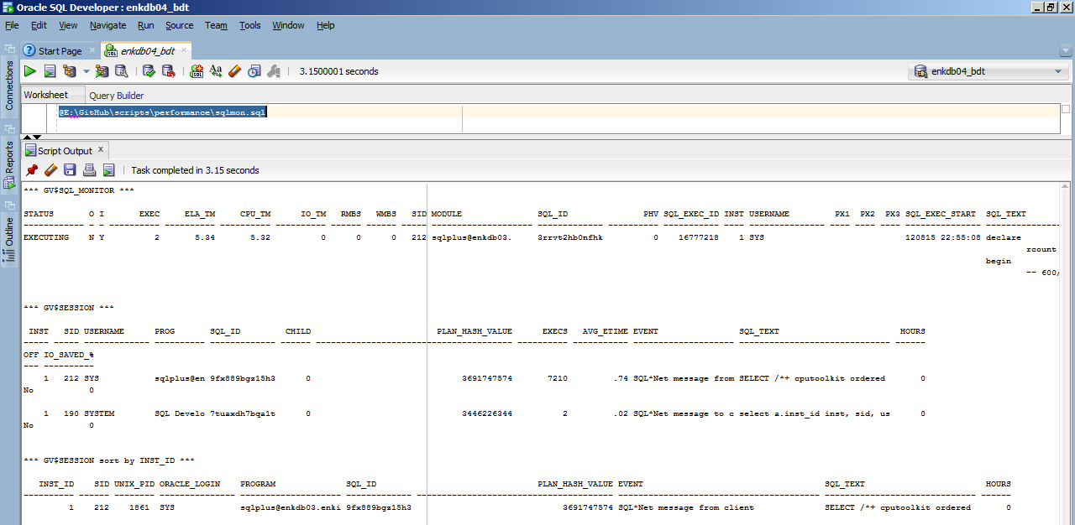

## ash_now

### Command line

|  |
| --- |
| $ cd scripts-master/performance/  $ sqlplus / as sysdba  SQL> @ash_now |

### SQL Developer

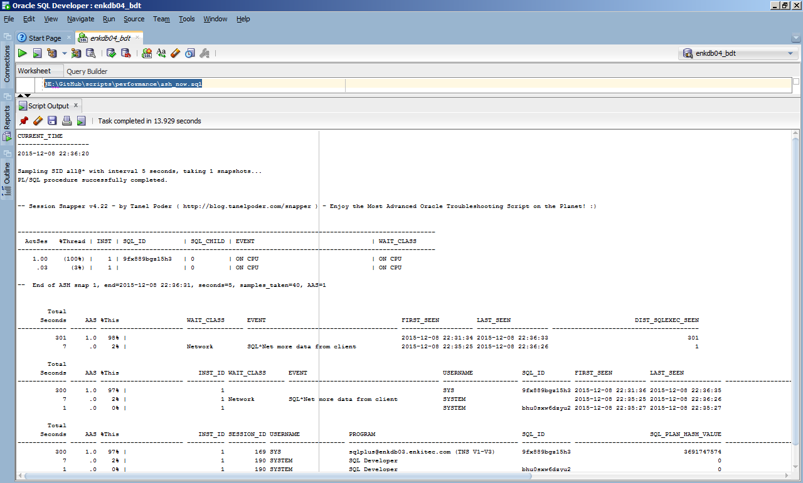

### Other commands

|  |
| --- |
| -- to get what part of the execution plan the SQL is spending most of its time  @@ashtop inst_id,session_id,username,program,sql_id,sql_plan_hash_value,plsql_entry_object_id,sql_plan_operation,sql_plan_options,sql_plan_line_id session_type='FOREGROUND' sysdate-5/24/60 sysdate |

## ash_history

### Command line

|  |
| --- |
| $ cd scripts-master/performance/  $ sqlplus / as sysdba  SQL> exec dbms_workload_repository.create_snapshot;  SQL> @ash_history  CURRENT_TIME  -------------------  2015-12-08 22:44:13  Enter start YYYY-MM-DD HH24:MI:SS -> 2015-12-08 22:30:00  Enter end YYYY-MM-DD HH24:MI:SS -> 2015-12-08 22:44:13 |

### SQL Developer

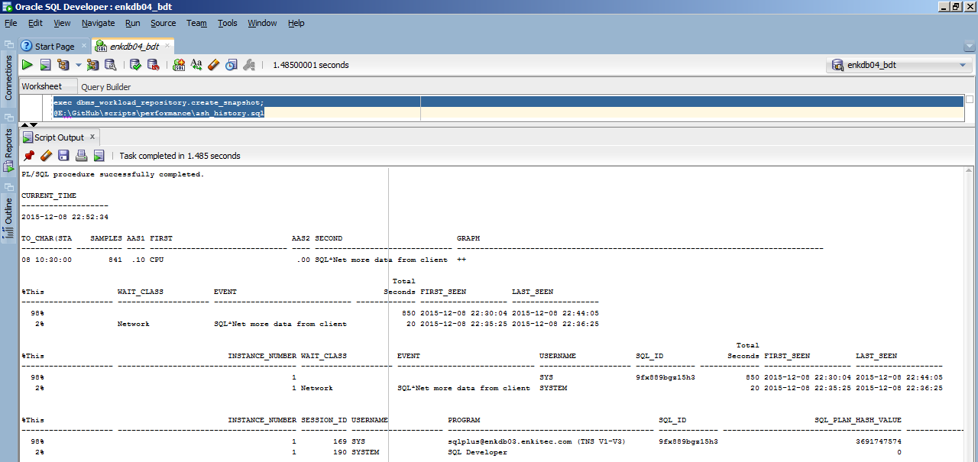

## snapper

### Command line

|  |
| --- |
| $ cd scripts-master/performance/  $ sqlplus / as sysdba  SQL> @snapper ash 5 1 all@* |

### SQL Developer

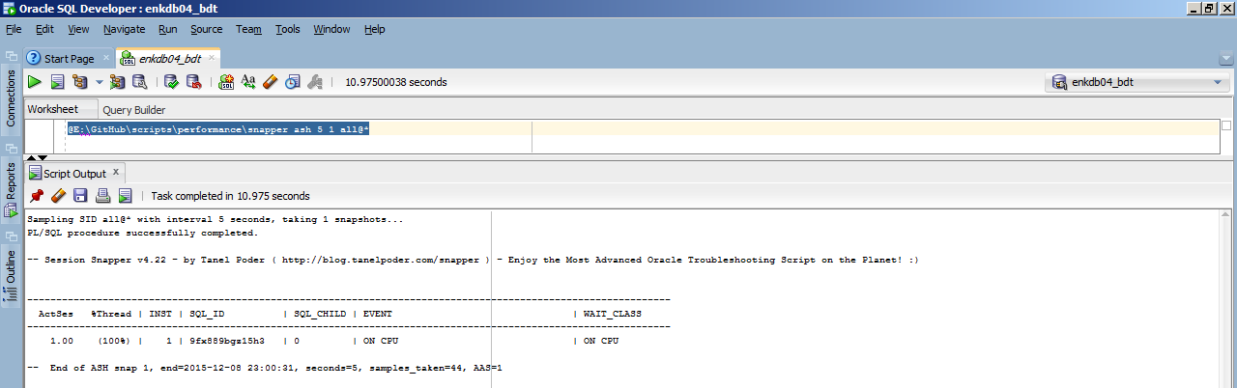

### Other commands

|  |
| --- |
| -- high level ASH workload characterization across instances  @snapper ash 5 1 all@*  -- by username on all instances  @snapper "ash=sql_id+sid+event+wait_class+module+service+blocking_session+p2+p3,stats" 5 1 user=APPUSER@*  -- all users on instance 1  @snapper "ash=sql_id+sid+event+wait_class+module+service+blocking_session+p2+p3,stats" 5 1 all@1  -- by SID on instance 1  @snapper "ash=sql_id+sid+event+wait_class+module+service+blocking_session+p2+p3,stats" 5 1 17@1  -- by inst_id,sid tuple syntax .. snapper on inst 2, SID 1234  @snapper ash 5 1 (2,1234)  -- comma separate to pass multiple inst_id,SID tuples  @snapper ash 5 1 (2,1234),(4,5678),(3,999)  -- snapper QC_ID run from any instance  @snapper ash 5 1 qc=1234@*  More here => http://blog.tanelpoder.com/2013/02/18/snapper-v4-02-and-the-snapper-launch-party-video/ |

## ash_wait_chains

### Command line

|  |
| --- |
| $ cd scripts-master/performance/  $ sqlplus / as sysdba  SQL> @ash_wait_chains.sql session_id||'>>'||program||'>>'||event||'>>'||sql_id||'>>'||sql_opname||'>>'||p1text||'>>'||p1||'>>'||blocking_session 1=1 sysdate-1/24/60 sysdate  -- Display ASH Wait Chain Signatures script v0.2 BETA by Tanel Poder ( http://blog.tanelpoder.com )  %This SECONDS AAS  ------ ---------- ----------  WAIT_CHAIN  --------------------------------------------------------------------------------------------------------------------------------------------------------------------------------------------------------------------------------------------------------------------  100% 60 1  -> **158**>>sqlplus@enkdb03.enkitec.com (TNS V1-V3)>>**enq: TX - row lock contention**>>**24afhzrp5w0dt**>>UPDATE>>name|mode>>1415053318>>**245** |

### SQL Developer

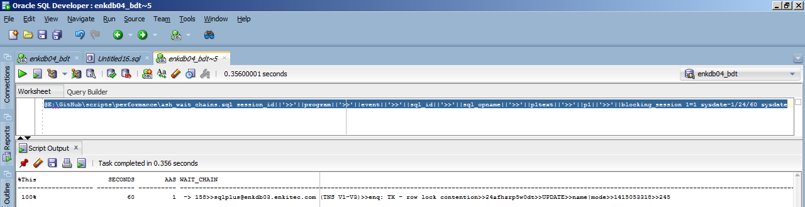

### Other commands

|  |
| --- |
| -- using TIMESTAMP  @<the script> username||':'||program2||event2 session_type='FOREGROUND' "TIMESTAMP'2014-11-19 17:00:00'" "TIMESTAMP'2014-11-19 18:00:00'"  More here => http://blog.tanelpoder.com/2013/09/11/advanced-oracle-troubleshooting-guide-part-11-complex-wait-chain-signature-analysis-with-ash_wait_chains-sql/ |

## gen_awr_report

### Command line

|  |
| --- |
| $ cd scripts-master/performance/  $ sqlplus / as sysdba  SQL> @gen_awr_report  Listing latest AWR snapshots ...  SNAP_ID END_INTERVAL_TIME  ---------- ---------------------------------------------------------------------------  1894 08-DEC-15 09.00.28.556 AM  1895 08-DEC-15 10.00.30.134 AM  1896 08-DEC-15 11.00.31.726 AM  1897 08-DEC-15 12.00.33.313 PM  1898 08-DEC-15 01.00.34.890 PM  1899 08-DEC-15 02.00.36.471 PM  1900 08-DEC-15 03.00.38.058 PM  1901 08-DEC-15 04.00.39.644 PM  1902 08-DEC-15 05.00.41.210 PM  1903 08-DEC-15 05.26.43.221 PM  1904 08-DEC-15 05.31.13.244 PM  1905 08-DEC-15 07.00.44.373 PM  1906 08-DEC-15 08.00.45.943 PM  1907 08-DEC-15 09.00.47.533 PM  1908 08-DEC-15 10.00.49.614 PM  1909 08-DEC-15 10.44.07.797 PM  1910 08-DEC-15 10.51.33.849 PM  1911 08-DEC-15 10.52.33.672 PM  1912 09-DEC-15 12.00.52.767 AM  1913 09-DEC-15 01.00.54.343 AM  1914 09-DEC-15 02.00.55.901 AM  1915 09-DEC-15 03.00.57.474 AM  1916 09-DEC-15 04.00.59.054 AM  1917 09-DEC-15 05.00.00.634 AM  1918 09-DEC-15 06.00.02.232 AM  1919 09-DEC-15 07.00.03.829 AM  1920 09-DEC-15 08.00.05.407 AM  27 rows selected.  Enter begin snapshot id: 1919  Enter end snapshot id: 1920  PL/SQL procedure successfully completed. |

### SQL Developer

* Hit cancel first to list the SNAP_IDs, then re-run the script
* Go to the C:\Users\<user>\AppData\Roaming\SQL Developer to get the report

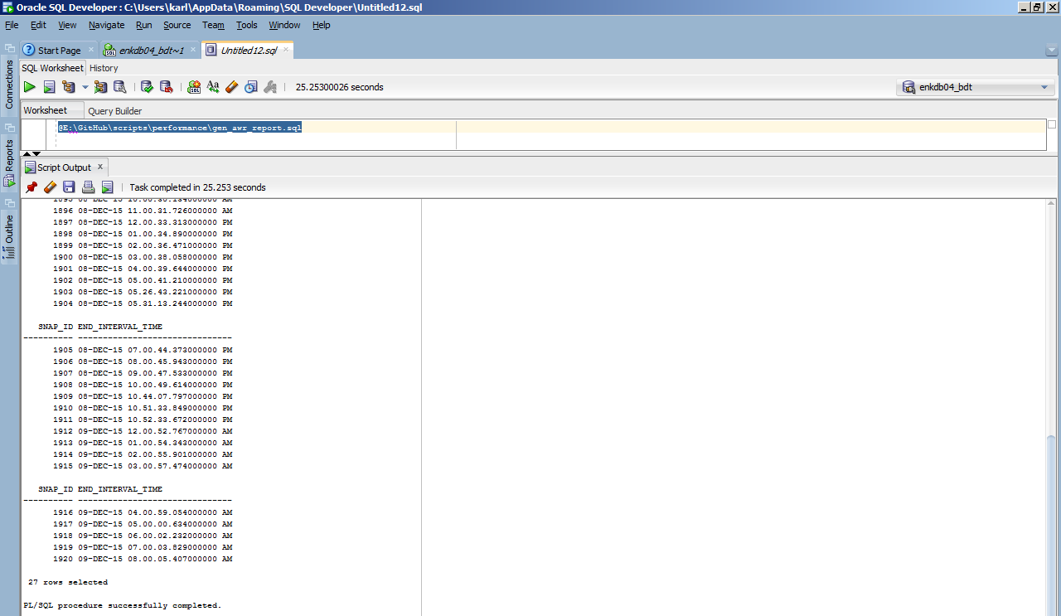

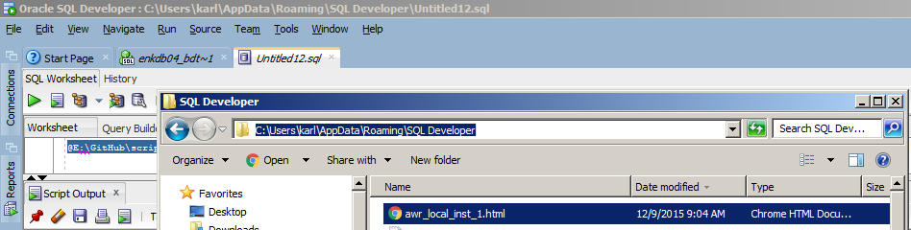

## gen_ash_report

### Command line

|  |
| --- |
| $ cd scripts-master/performance/  $ sqlplus / as sysdba  SQL> @gen_ash_report  Enter begin time [2015-12-09 07:11]: 2015-12-09 07:11  Enter end time [2015-12-09 08:11]: 2015-12-09 08:11  PL/SQL procedure successfully completed.  Spooling into ash_report.html  Done. |

### SQL Developer

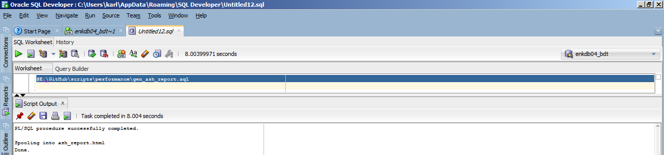

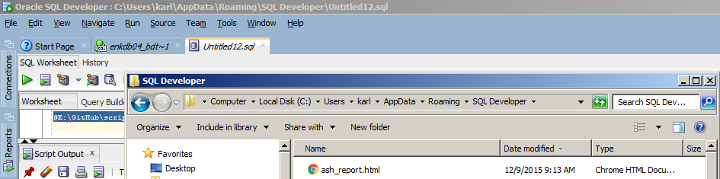

# SQL troubleshooting

Download at <https://github.com/karlarao/scripts/archive/master.zip>

## sqlhc

### Command line

|  |
| --- |
| $ cd scripts-master/performance/  $ sqlplus / as sysdba  SQL> @sqlhc T 9fx889bgz15h3 |

## planx

### Command line

|  |
| --- |
| $ cd scripts-master/performance/  $ sqlplus / as sysdba  SQL> @planx Y 9fx889bgz15h3 |

## SQL Monitor report

### Command line

|  |
| --- |
| $ cd scripts-master/performance/  $ sqlplus / as sysdba  SQL> @report_sql_monitor_html  SQL> @report_sql_monitor_detail_html |

### SQL Developer

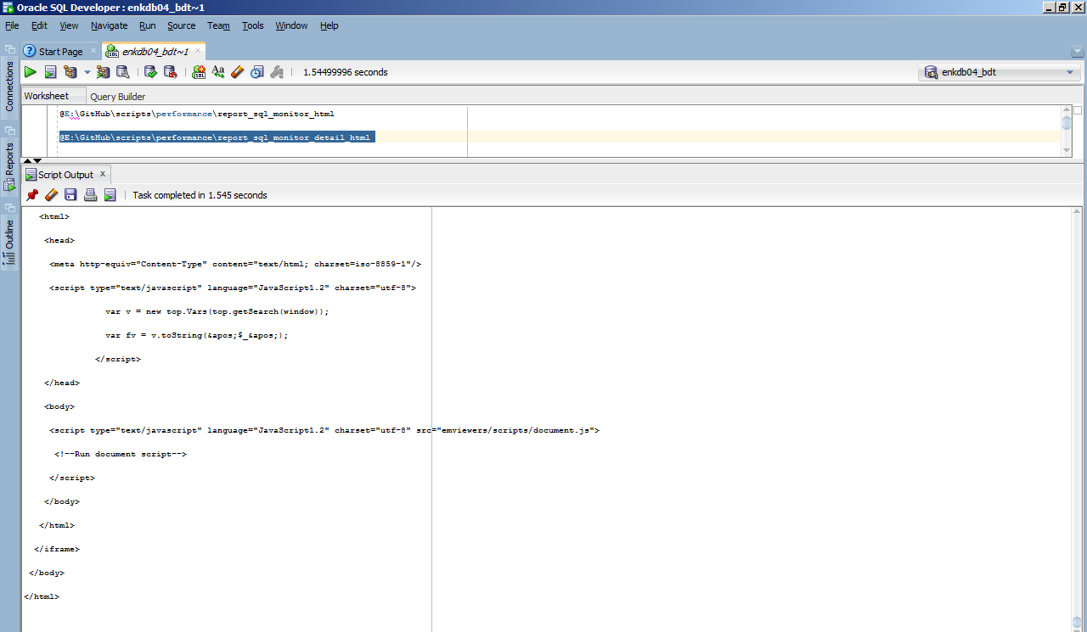

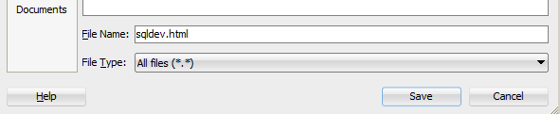

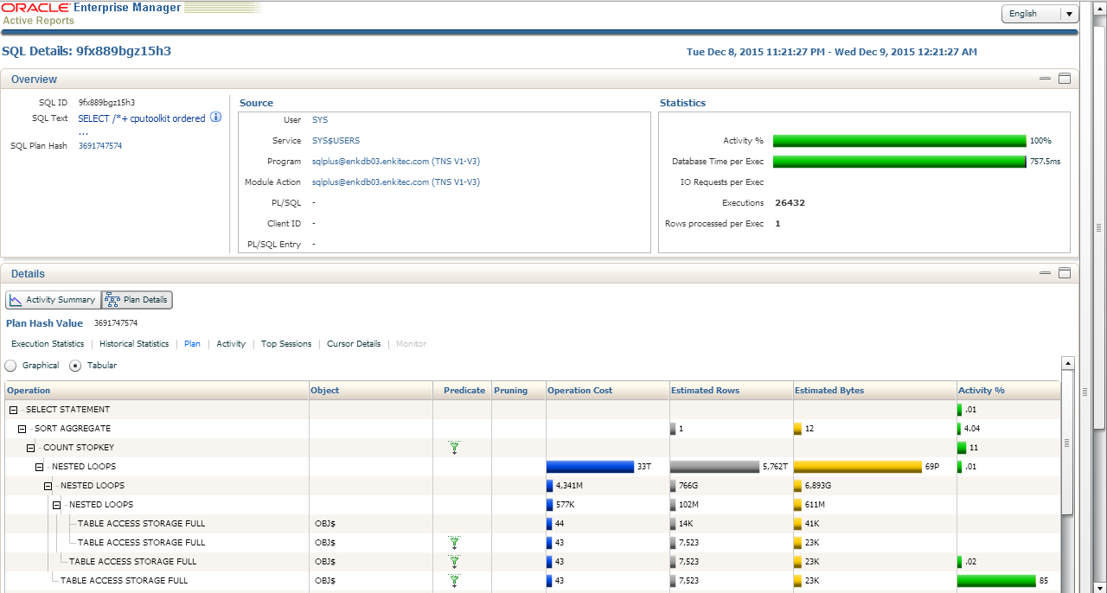

## Parallel SQLs and PX stats

### Command line

|  |
| --- |
| $ cd scripts-master/performance/  $ sqlplus / as sysdba  SQL> @px |